 National University

of Computer and Emerging Sciences

Chiniot-Faisalabad Campus

**CL1000 – Introduction to Information and Communication Technology**

**Final Project Proposal**

**Fall 2022**

**Group Members**

Ayesha Nazir - 22F-3254

Jaweria Rehman - 22F-3352

Meher Akbar - 22F-8796

Minahil Usman - 22F-8760

**Submission date**

28th November, 2022

**Submitted To**

Mr. Shahbaz Ayyaz

***Project Idea***

We are going to create an interactive and user-friendly online clothing business website by the name of **“NSMNIA Wardrobe”.** Keeping people satisfied with the outlook of your website is crucial in order to make sure the customers come again and again to buy from your website not only for the brand’s quality but also due to easily provided through a user-friendly website. Our website will provide people all such features that buying online clothes will become a joyful and interesting activity for them. We will create nice and aesthetic clothes representation that will excite the customers to buy things from our brand. Our ultimate goal is to create such a website that create a trustful environment between seller and our customers and ensure that they will have such a nice experience that they visit our website whenever they want to buy online clothes.

***Features***

The website will have the following features:

* A navigation bar to navigate easily through the different pages of the website for pages like home, clothes, accessories, shoes, contact, about us in the header part of the website.
* It will have a slider images display on the default screen which would display attractive images to peak customer’s interests as well as talk about any special sales happening at the moment.
* Each product will contain an information table that will provide information that in how many colours and sizes that product is available in along with its cost and then can be clicked on further to check product description and imagery.
* Each product will have a review box where the customer can give their review about design and fabric quality etc.
* A table of choice will also be part of header where the customers will choose which type of clothes they want i.e. luxury, pret, casual or etc.
* The website will have a form to login register to the business so they can get updates on their email about upcoming launches and sales.
* A shopping cart & account login option will also be there in header.
* A search tab would be included in the header.
* The footer will have contact information, newsletter sign up, customer care to deal with things like FAQs and information to display blog posts related to our business.
* Each product when selected would lead to another page to display product picture, its cost, description and a size chart would be displayed upon selection.
* There would also be links added to social media pages of the business so the customers can easily follow up on the brand through it.
* 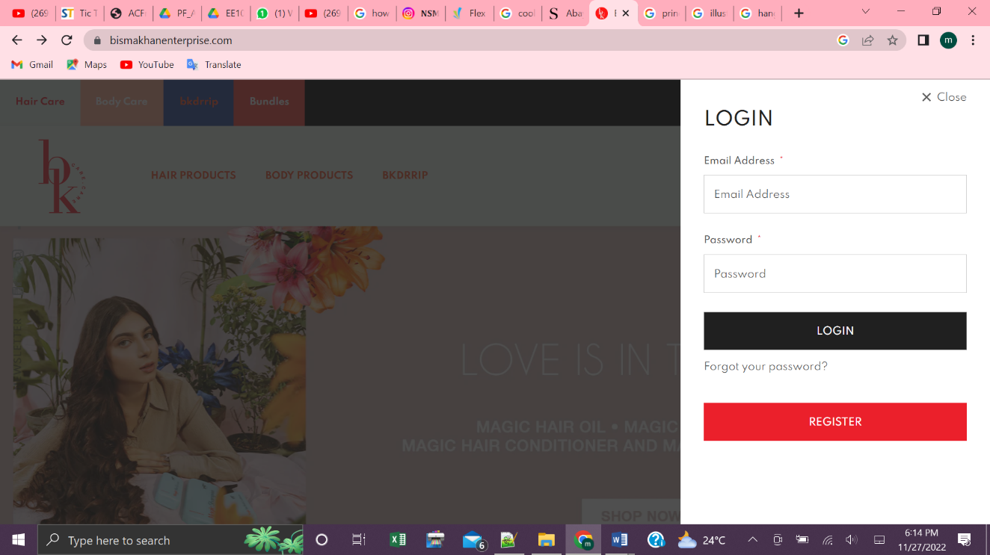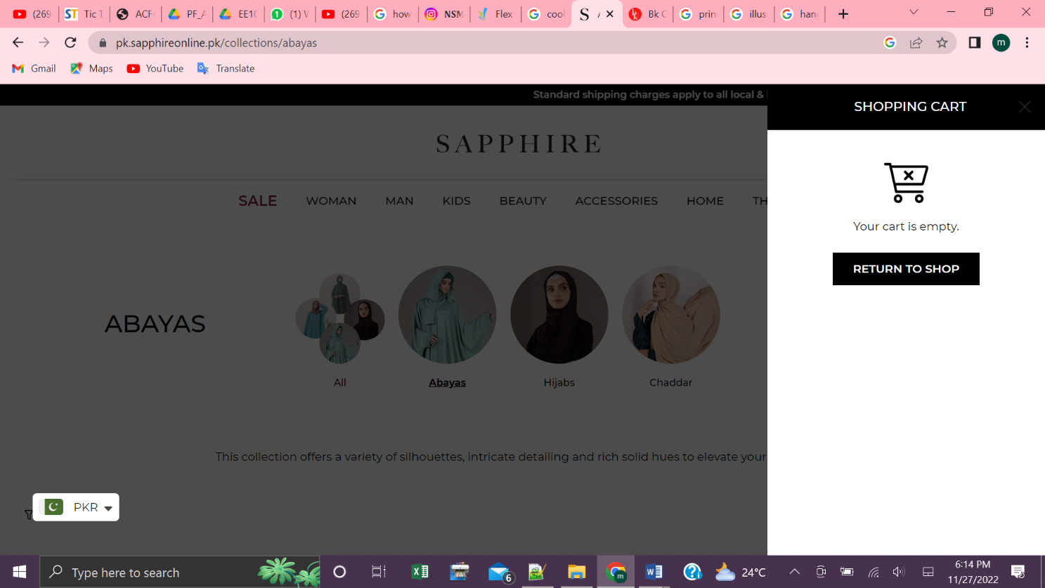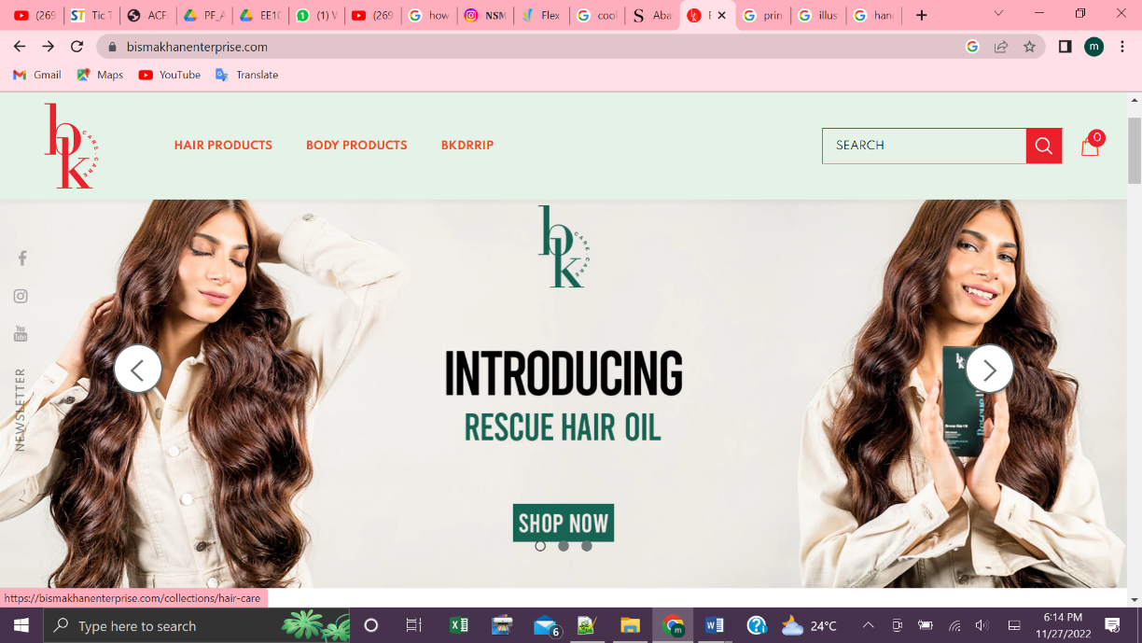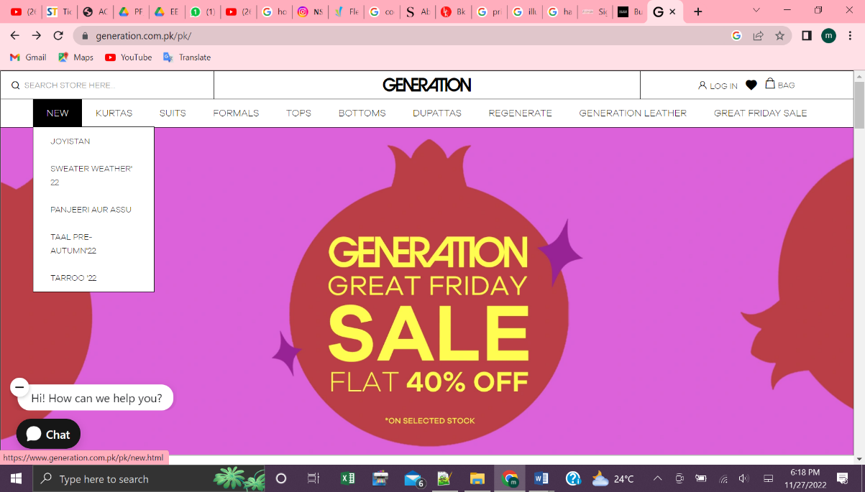There will be a default page available that could be accessed through a specified button like a heart that would open the page and just show the special offers of the brand and imagery of latest collections.

Fig. 1 Shopping cart to manage orders

Fig. 2 General Outlook of the website

Fig. 3 Slider menu as such to display offers

Fig. 4 Login menu to register

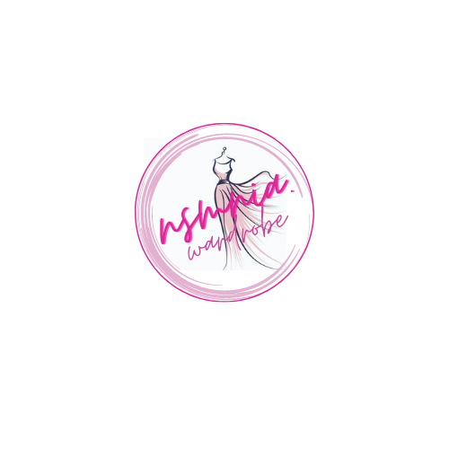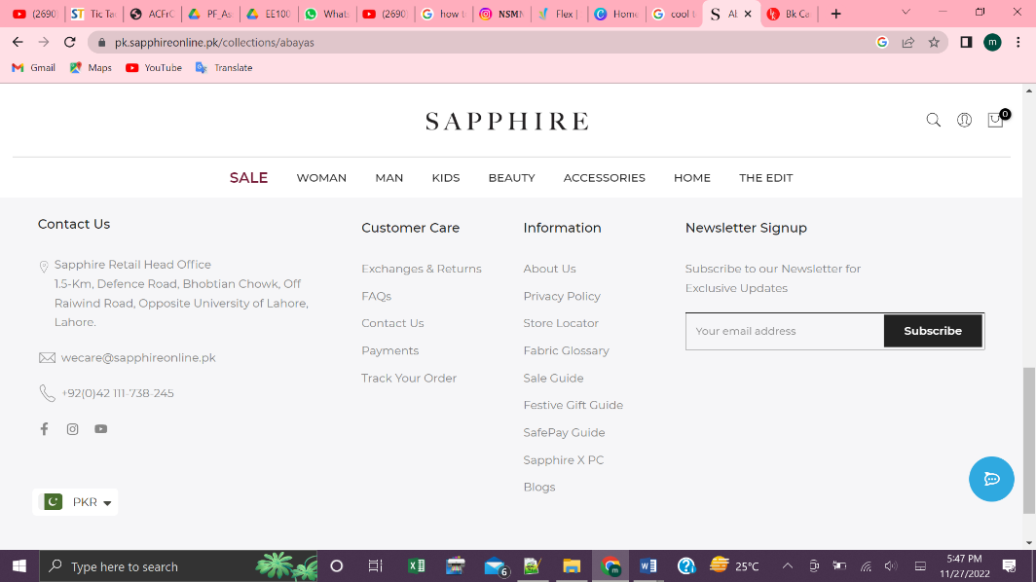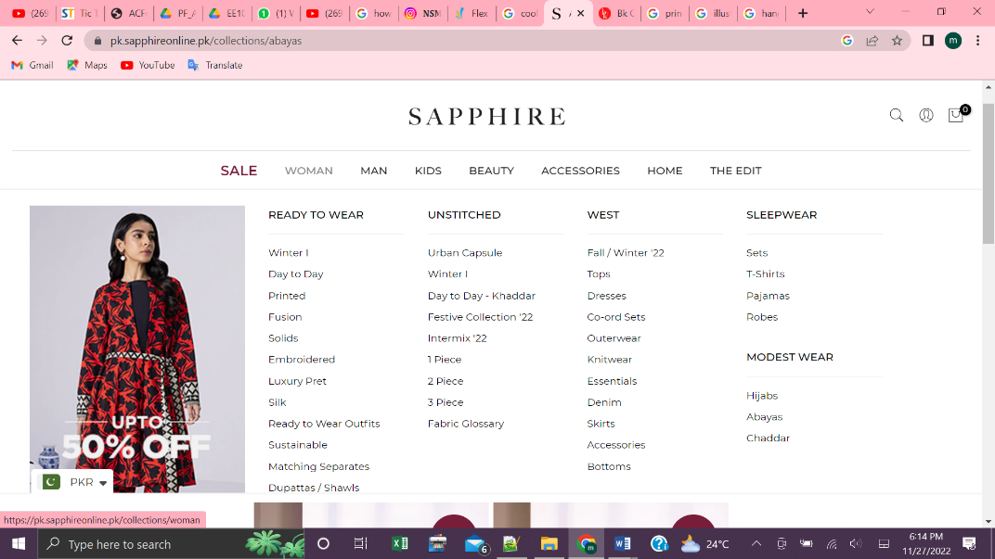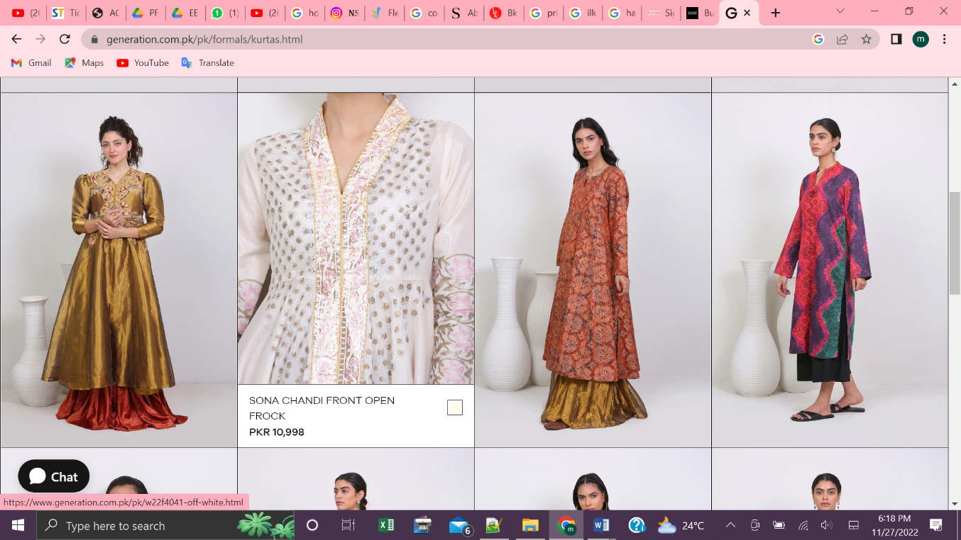

Fig. 5 Logo for the brand

Fig. 6 How products could be shown

Fig. 7 Menu to browse through different items available

Fig. 8 Footer of the website

***Description***

Nsmnia Wardrobe is a brand that lives on the principle of ensuring the best quality clothing to women all over the country that they can enjoy at their doorsteps. The brand deals in with casual, pret and luxury wear for women which have been stitched with the finest craftsmanship. It also provides accessories to make their outfits pop. Customers are a huge priority whom Nsmnia wants to make them feel *classy since birth* when they step out in their exquisite outfits. In order to make sure the customers will always an amazing experience while shopping at Nsmnia. The world has gone digital and so has Nsmnia, their online shopping site provides the customers with an easy to use platform to shop for their favourite items with the best deals and customer service.

